**Week 2 - Assignment**

1. **Illustrate AVERAGEIF function using below worksheet**

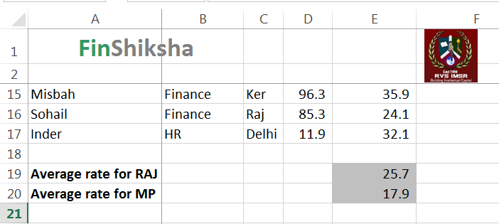

1. **Illustrate the way to perform SUMPRODUCT function in the below excel sheet.**

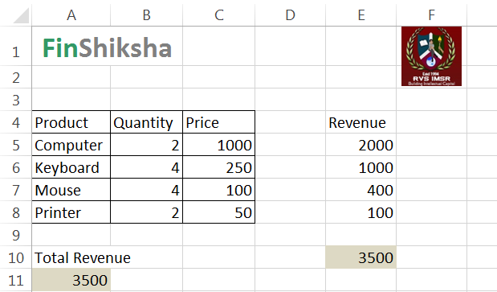

1. **Describe the Exact LOOKUP using below excel sheet.**

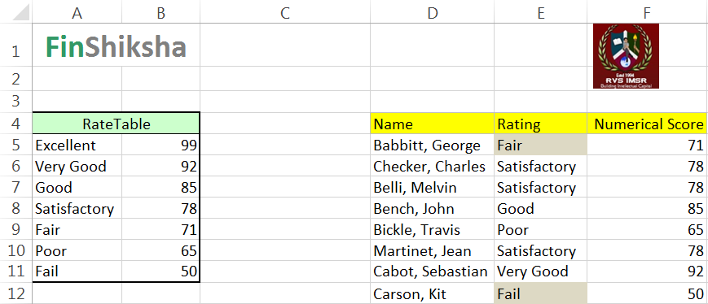

1. **Write down the steps to Calculate the Depreciation value for the below worksheets**

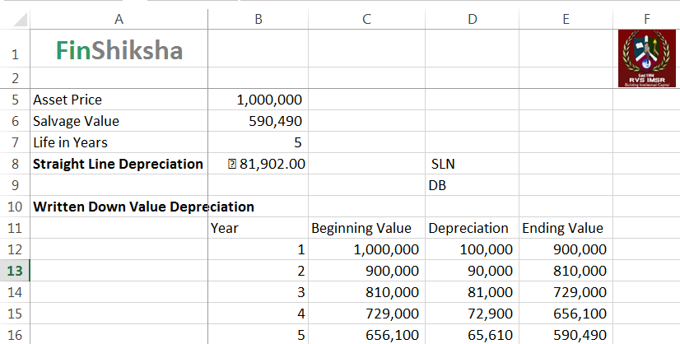

1. **Write down the steps to Calculate the CAGR value for the below worksheets**

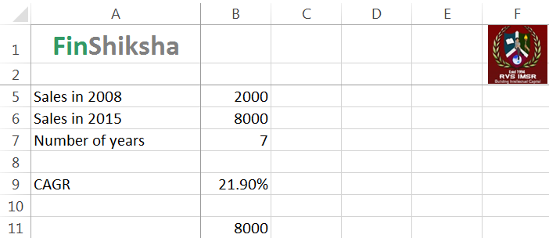

1. **Using the conditional formatting perform Status and Trend for the Quarters for the below excel**



  